

**PROTOCOL**to exercise

***PCM***

|  |  |  |
| --- | --- | --- |
| Group / Class | Secretary | Signature |
| 5 / **3BHEL** | **HOFSTÄTTER A.** | ***e.h.*** |
| Exercise- / Delivery date | Employee | Signature |
| 24th February 2014 |  |  |
| Teacher | Employee | Signature |
| GRASINGER |  |  |
| Grade | Employee | Signature |
|  |  |  |
| ***PCM***  ***(Puls Code Modulation)*** | | |
| **Used Programs**   |  |  |  | | --- | --- | --- | | Nr. | Name | Version | | 1. | **audioTester** | **1.4** | | 2. | **Cool Edit Pro** | **1.2** | | | |

ÜBUNGS-/ABGABE-DATUM

Klasse /Gruppe

NOTE

LEHRER

# Contents

1 Contents 2

2 Tasks 3

2.1 Used Programs 3

2.1.1 audioTester 3

2.1.2 Cool Edit Pro 3

2.2 General Measurement Setup 3

3 First Signal 4

3.1 Characteristics of the signal 4

3.2 Measurement Results 4

3.2.1.1 General Signal Waveform 4

3.2.1.2 Spectrum Analysis 4

4 Second Signal 5

4.1 Characteristics of the signal 5

4.2 Measurement Results 5

4.2.1.1 General Signal Waveform 5

4.2.1.2 Spectrum Analysis 5

5 Third Signal 6

5.1 Characteristics of the signal 6

5.2 Measurement Results 6

5.2.1.1 General Signal Waveform 6

5.2.1.2 Spectrum Analysis 6

6 Fourth Signal 7

6.1 Characteristics of the signal 7

6.2 Measurement Results 7

6.2.1.1 General Signal Waveform 7

6.2.1.2 Spectrum Analysis 7

7 Fifth Signal 8

7.1 Characteristics of the signal 8

7.2 Measurement Results 8

7.2.1.1 General Signal Waveform 8

7.2.1.2 Spectrum Analysis 8

9 Register of Illustrations 9

# Tasks

The task of this exercise was to compare different speech coding algorithms.

The following 4 signals were generated with the Program *audioTester.*

|  |  |  |  |  |  |
| --- | --- | --- | --- | --- | --- |
| Signal nr. | 1 | 2 | 3 | 4 | 5 |
| Frequency | 450Hz | 4500Hz | 450Hz | 450Hz | 450Hz |
| Level | 0dB | 0dB | -30dB | -30dB | -30dB |
| Sample Rate | 8kHz | 8kHz | 8kHz | 8kHz | 8kHz |
| Resolution | 16Bit | 16Bit | 8Bit | A-law | 32kb/s ADPCM |

Table 1. Given Signals

## Used Programs

### audioTester

AudioTester is a program building an audio-Laboratory with the use of a sound card. Audiotester provides you with a frequency generator a Oscilloscope and a spectrum analyser using the soundcard (sound chip).

Before measuring signals with audioTester the PC has to be calibrated using the frequency generator (line out) connected to audioTesters oscilloscope (line in). Calibrating means that the mixer is set to the maximum level that is possible without clipping.

### Cool Edit Pro

Cool Edit pro is a waveform editing program providing Waveform recording, analysis and storage of the recorded waveforms in different coding standards like PCM, A-and μ law and ADPCM. The effect of different coding methods can be investigated by storing a recorded waveform and compare the stored and re-opened signal file with the original waveform.

## General Measurement Setup

The given signal was generated with the program audioTester on the computer. Afterwards the signal was forwarded to the sound card of the pc. At the soundcard an external loop was created. A Stereo cable was connected from the *OUTPUT* to the *LINE-IN* connector.

So the output is directly connected to *LINE-IN*. This has the effect that the signal could be analysed like a normal signal on the LINE-IN port.

For signal analysis the program Cool Edit Pro was used. It also provides waveform editing, saving and storage as well as the use different coding methods and standards.

# First Signal

## Characteristics of the signal

Frequency: 450 Hz - Level: 0 dB – Sample Rate: 8 kHz – Resolution: 16 Bit

## Measurement Results

A sinus has only one peak at its ground frequency. The noise (distortion) value is -87dB. Here you can see the samples of a 450 Hz sinus waveform. There are no anomalies.

#### General Signal Waveform

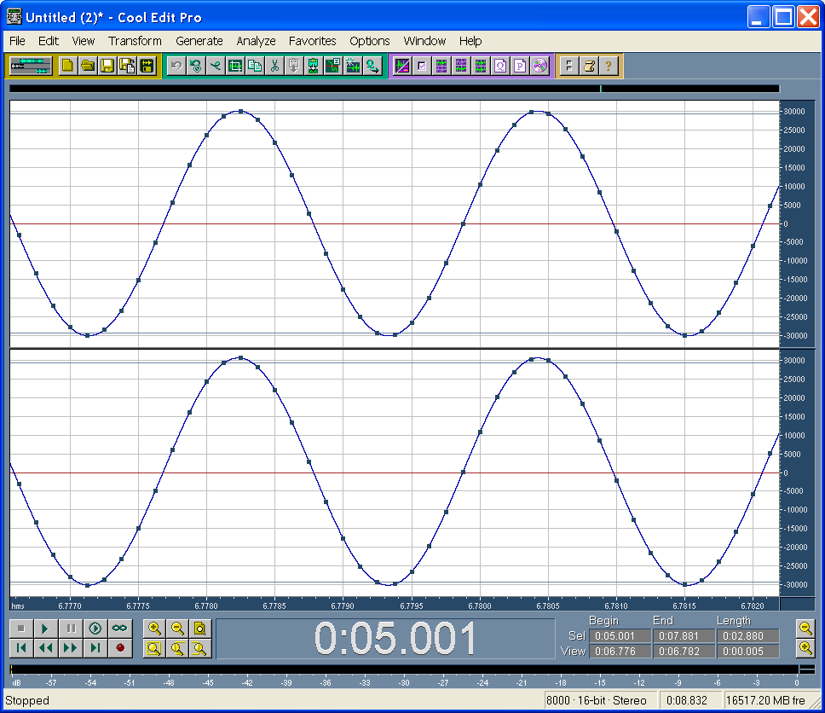

Figure 1. Waveform of Signal 1

#### Spectrum Analysis

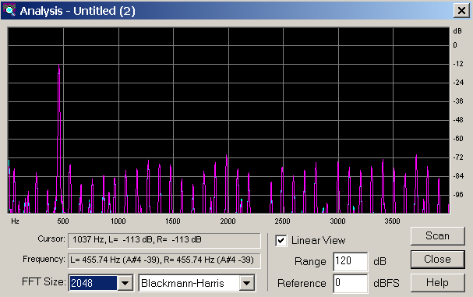

Figure 2. Spectrum Analysis of Signal 1

# Second Signal

## Characteristics of the signal

Frequency: 4500 Hz - Level: 0 dB – Sample Rate: 8 kHz – Resolution: 16 Bit

## Measurement Results

The peak is out of scale. A sinus wave has only one peak at its ground frequency. Also this signal courses an aliasing effect, because the frequency is higher than the half of the sampling frequency (sampling theorem of Shannon).

#### General Signal Waveform



Figure 3. Waveform of Signal 2

#### Spectrum Analysis

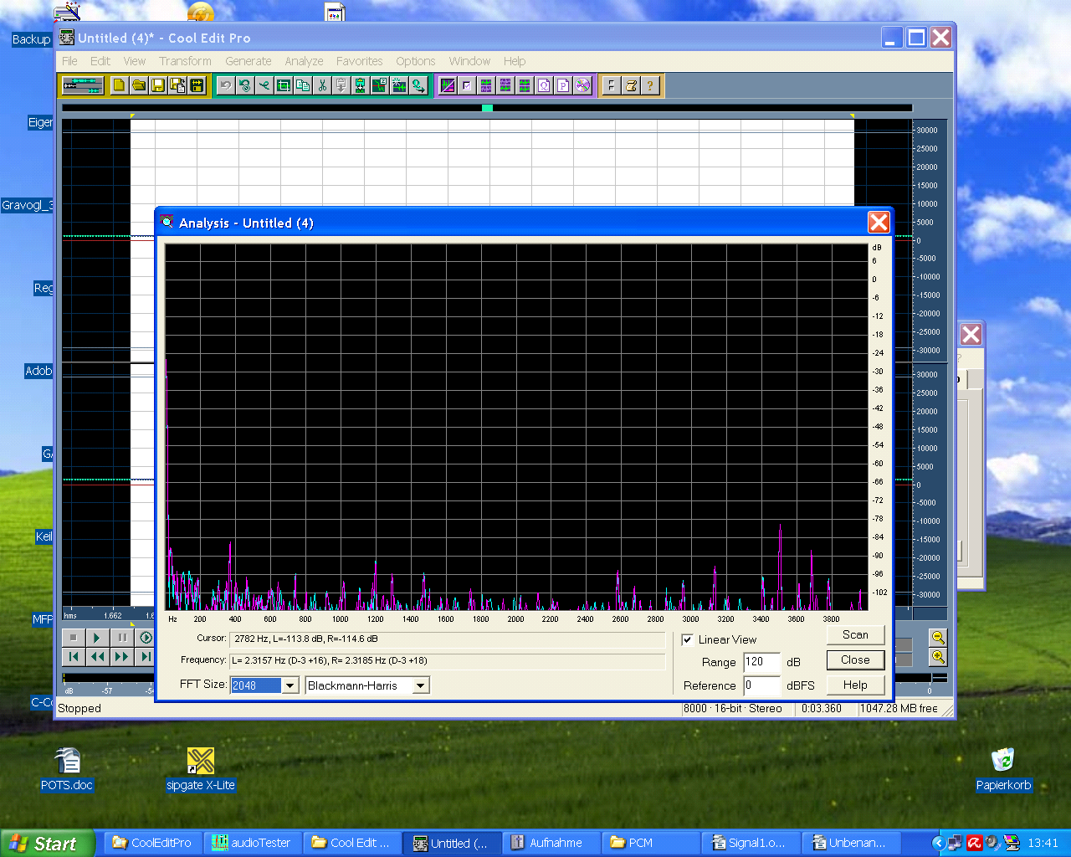

Figure 4. Spectrum Analysis of Signal 2

# Third Signal

## Characteristics of the signal

Frequency: 450 Hz - Level: -30 dB – Sample Rate: 8 kHz – Resolution: 8 Bit

## Measurement Results

The noise (distortion) value is -59dB.Something could be seen but the quality is very bad.

From this spectrum analysis you can see that the peak on channel 1 (blue) is lower than that on channel 2. The contrast between signal and noise is less.

#### General Signal Waveform

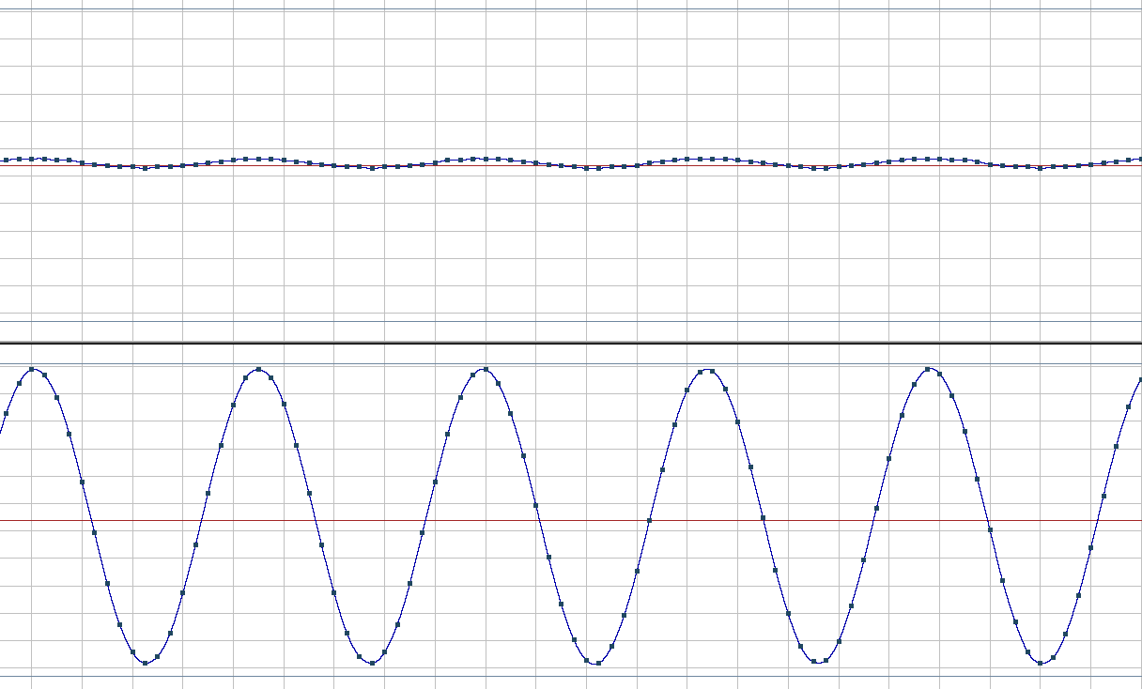

Figure 5. Waveform of Signal 3

#### Spectrum Analysis

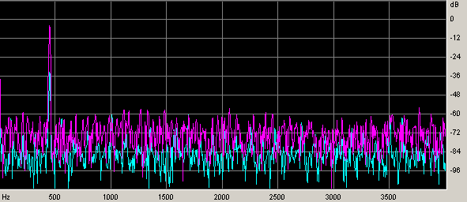

Figure 6. Spectrum Analysis of Signal 3

# Fourth Signal

## Characteristics of the signal

Frequency: 450 Hz - Level: -30 dB – Sample Rate: 8 kHz – Resolution: A-law

## Measurement Results

The noise (distortion) value is -74dB.

Here the quality is much better, than it was in the 3rd signal, but the noise value is also quite high. At this figure you can see that the noise level on A-Law is far more than on 8Bit resolution. This effects on both channels and is for the -30dB signal far more dangerous.

#### General Signal Waveform

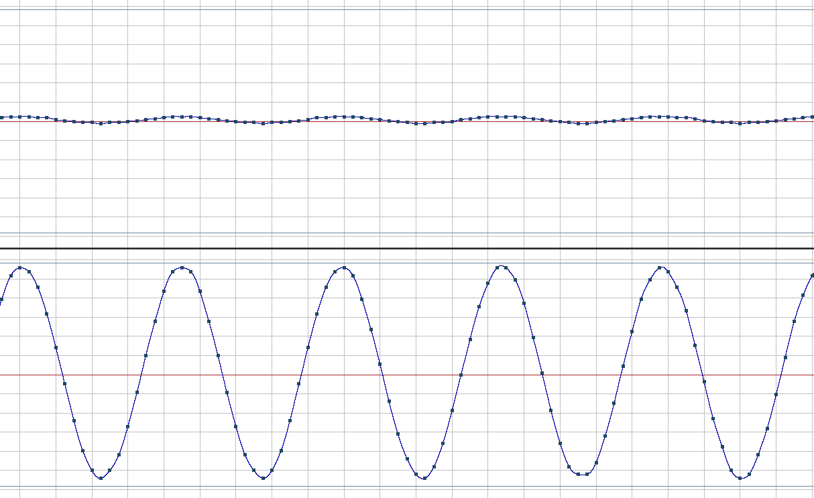

Figure 7. Waveform of Signal 4

#### Spectrum Analysis



Figure 8. Spectrum analysis of Signal 4

# Fifth Signal

## Characteristics of the signal

Frequency: 450 Hz - Level: -30 dB – Sample Rate: 8 kHz – Resolution: 32 kB/s ADPCM (Microsoft)

## Measurement Results

The noise (distortion) value is -83dB.

From the three low level signals, this one has the best quality.

#### General Signal Waveform

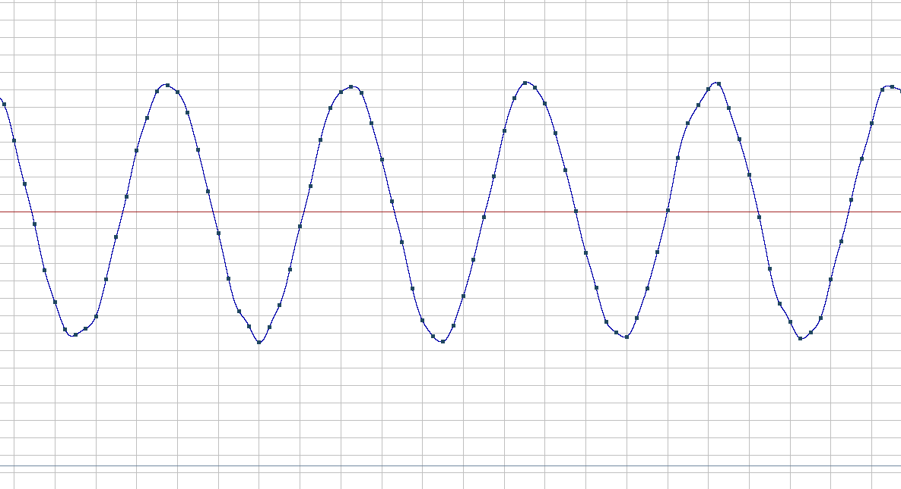

Figure 9. Waveform of Signal 5

#### Spectrum Analysis

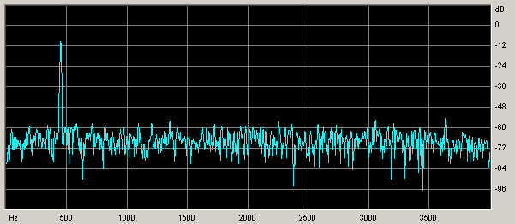

Figure 10. Spectrum Analysis of Signal 5

# Register of Illustrations

Figure 1. Waveform of Signal 1 4

Figure 2. Spectrum Analysis of Signal 1 4

Figure 3. Waveform of Signal 2 5

Figure 4. Spectrum Analysis of Signal 2 5

Figure 5. Waveform of Signal 3 6

Figure 6. Spectrum Analysis of Signal 3 6

Figure 7. Waveform of Signal 4 7

Figure 8. Spectrum analysis of Signal 4 7

Figure 9. Waveform of Signal 5 8

Figure 10. Spectrum Analysis of Signal 5 8